Lab-3
1:Write a program to create an array of integers and perform following operations on that array like
finding the sum, average, maximum and minimum number in that array. Accept the numbers of the
array from user.

#include <iostream>
using namespace std;

int main() {
int n;
cout << "Enter the number of elements in the array: ";
cin >> n;

int arr[n];
cout << "Enter " << n << " integers:" << endl;
for (int i = 0; i < n; i++) {
cin >> arr[i];
}

int sum = 0, max = arr[0], min = arr[0];
for (int i = 0; i < n; i++) {
sum += arr[i];
if (arr[i] > max) {
max = arr[i];
}
if (arr[i] < min) {
min = arr[i];
}
}

double average = static_cast<double>(sum) / n;

cout << "Sum: " << sum << endl;
cout << "Average: " << average << endl;
cout << "Maximum: " << max << endl;
cout << "Minimum: " << min << endl;

return 0;
}

Output:
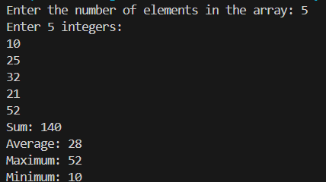

2: Write a program to Accept a number and display its sum of digits.:ex 568 5+6+8

#include <iostream>
using namespace std;

int main(){
int num,sum=0, digit;
cout<<"Enter a number: ";
cin>>num;
while(num>0){
digit = num% 10;
sum = sum + digit;
num = num / 10;
}
cout<<"Sum of digits is: "<<sum<<endl;
return 0;
}

Output:
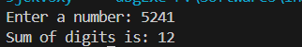

3:. Write a program to find sum of all even and odd numbers between 1 to n.

#include<iostream>
using namespace std;
int main(){
int n, evenSum=0, oddSum=0;
cout<<"Enter a number: ";
cin>>n;
for(int i=1; i<=n; i++){
if(i%2==0){
evenSum += i;
} else {
oddSum += i;
}
}
cout<<"Sum of even numbers: "<<evenSum<<endl;
cout<<"Sum of odd numbers: "<<oddSum<<endl;
return 0;
}

Output:
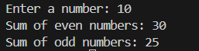

4:. Write a program to print all Prime numbers between 1 to n.

#include <iostream>
using namespace std;

int main() {
int n;
cout << "Enter a number: ";
cin >> n;
cout << "Prime numbers between 1 and " << n << " are:" << endl;
for (int i = 2; i <= n; i++) {
bool isPrime = true;
for (int j = 2; j * j <= i; j++) {
if (i % j == 0) {
isPrime = false;
break;
}
}
if (isPrime) {
cout << i << " ";
}
}
cout << endl;
return 0;
}

Output:
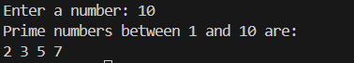

5:Write a program to accept array from user .Accept number from user and search number is present in array or not.

#include <iostream>
using namespace std;
int main() {
int n, searchNum;
cout << "Enter the number of elements in the array: ";
cin >> n;

int arr[n];
cout << "Enter " << n << " integers:" << endl;
for (int i = 0; i < n; i++) {
cin >> arr[i];
}

cout << "Enter a number to search: ";
cin >> searchNum;

bool found = false;
for (int i = 0; i < n; i++) {
if (arr[i] == searchNum) {
found = true;
break;
}
}

if (found) {
cout << searchNum << " is present in the array." << endl;
} else {
cout << searchNum << " is not present in the array." << endl;
}

return 0;
}

Output:
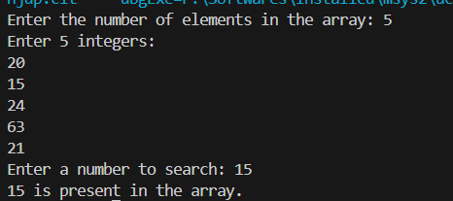
6:Write a program to print following pattern.

*
* *
* * *
* * * *
* * * * *

#include <iostream>
using namespace std;

int main() {
int n;
cout << "Enter the number of rows: ";
cin >> n;

for (int i = 1; i <= n; i++) {
for (int j = 1; j <= i; j++) {
cout << "* ";
}
cout << endl;
}
return 0;
}

Output:
